
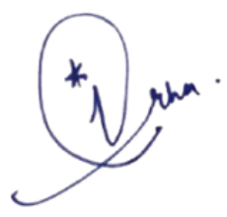

Principal Signature
OF APPRECIATION
This is to certify that
{{name}}
of Class {{class}}
has secured {{Medal}} Medal
in {{competition_name}}

